Programming assignment 2

Python has built in functions for the basic logic operations of “and”, ”or”, and “not” but not for implies or if and only if. Define two functions, implies and iff that will take as arguments p and q which can take on the value True or False and return the output of the implies and if and only if operators. See my example below.

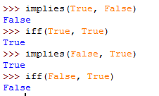

Test your functions for all 4 possible inputs to insure it works. I need to see those results in your submission.